AMES-HOUSING DATASET
Integrated Seven-Week Data Science Report
Data Science & Visualization • Course 24ADI204

Executive Summary
This report brings together the work completed across seven weeks using the Ames Housing dataset. The dataset describes homes in Ames, Iowa, including their features and final selling prices. The project began by understanding the data and gradually moved through cleaning, visualization, feature preparation and dimensionality reduction. Throughout the work, SalePrice was treated as the main variable to be studied and eventually predicted.

Milestone | Main work | Reported outcome
Week 1 | Dataset understanding | 3,130 rows, 82 columns, 17,010 missing cells (about 6.63%).
Week 2 | Exploratory visual analysis | SalePrice is right-skewed; Overall Qual and Gr Liv Area show strong positive relationships with price.
Week 3 | Cleaning and outlier review | 200 exact duplicate rows removed; dataset reduced to 2,930 rows; missingness assessed and handled in stages.
Week 4 | Deeper EDA | Univariate and bivariate analysis, categorical comparisons and correlation heatmap.
Week 5 | Data audit and statistics | 2,930 rows × 82 columns; zero missing values and zero duplicates reported in the audited dataset.
Week 6 | Feature engineering and encoding | Five derived features; log1p target transform; final encoded matrix of 2,930 × 293.
Week 7 | Feature selection and PCA | 40 curated features selected; PCA retains 95% variance with 175 components from 279 input features.

Key findings at a glance
- Overall Qual has the strongest reported linear correlation with SalePrice (r = +0.799).
- Gr Liv Area is also strongly associated with SalePrice (r = +0.707).
- SalePrice skewness falls from +1.74 to +0.12 after the reported log1p transformation.
- Random Forest importance is concentrated in Overall Qual (49.73%) and TotalHouseArea (28.05%) in the Week 7 report.
- Feature selection retains 40 curated predictors; PCA uses 175 components to preserve 95% of variance.
Interpretation note: These are associations and reported workflow outcomes, not proof of causation or a completed predictive-model performance evaluation.

1. Project Aim and Scope
The main goal of this project is to prepare housing data so it can be explored clearly and used for future house-price prediction. Across the seven weeks, we studied the dataset, visualized patterns, cleaned missing and duplicate values, summarized the statistics, created useful features, scaled and encoded the data, and explored feature selection and Principal Component Analysis (PCA). A final prediction model and its test accuracy are not included in the weekly reports, so this document focuses on the analysis and preparation completed so far.

2. Dataset Overview
The original dataset contains 3,130 property records and 82 columns, giving a total of 256,660 cells. The columns describe several aspects of each home, including its location, size, construction, quality, basement, rooms, garage and outdoor features. The final sale price, recorded in SalePrice, is the main outcome of interest.

Dataset property | Reported value
Initial dimensions | 3,130 rows × 82 columns
Initial cells | 256,660
Initial missing cells | 17,010 (approximately 6.63%)
Audited cleaned dataset | 2,930 rows × 82 columns
Feature-engineered dataset | 2,930 rows × 293 columns
Week 7 PCA output | 2,930 rows × 179 columns, including IDs and targets

Important variable groups
Group | Examples | Why relevant
Property quality | Overall Qual, Overall Cond, Kitchen Qual | Captures finish and condition differences.
Area and layout | Gr Liv Area, Total Bsmt SF, 1st Flr SF, TotRms AbvGrd | Represents usable space and layout.
Age and renovation | Year Built, Year Remod/Add | Provides construction and modernity context.
Garage and amenities | Garage Cars, Garage Area, TotalPorchArea | Represents parking and outdoor features.
Location and category | Neighborhood, House Style, MS Zoning | Captures differences between locations and property types.
Sale outcome | SalePrice, Yr Sold, Sale Type | Provides the target and transaction context.

3. Seven-Week Workflow
Week | Stage | Purpose / deliverable
1 | Dataset description | Identify dimensions, feature groups, missingness and SalePrice target.
2 | Initial visualization | Inspect missing values, distributions, correlations and categorical price differences.
3 | Cleaning | Compare raw and cleaned data, treat missingness, remove duplicates and screen outliers.
4 | EDA deep dive | Run univariate and bivariate analyses and inspect correlation patterns.
5 | Statistical audit | Verify completeness and summarize mean, median, spread, skewness and correlations.
6 | Feature engineering | Create composite features, transform target, scale values and encode categories.
7 | Dimensionality reduction | Select useful predictors and apply PCA with variance-retention analysis.

Tools reported across the workflow include Python, Pandas, NumPy, Matplotlib and Seaborn; Week 7 additionally reports scikit-learn selection and PCA methods.

4. Data Cleaning and Quality Audit
In Week 3, the cleaning comparison showed that 200 duplicate records had been removed. The dataset therefore decreased from 3,130 to 2,930 rows, while all 82 columns were kept. At that stage, the number of missing cells had fallen from 17,010 to 15,066. The Week 5 audit later reported no remaining missing values and no duplicate rows after further treatment and imputation.
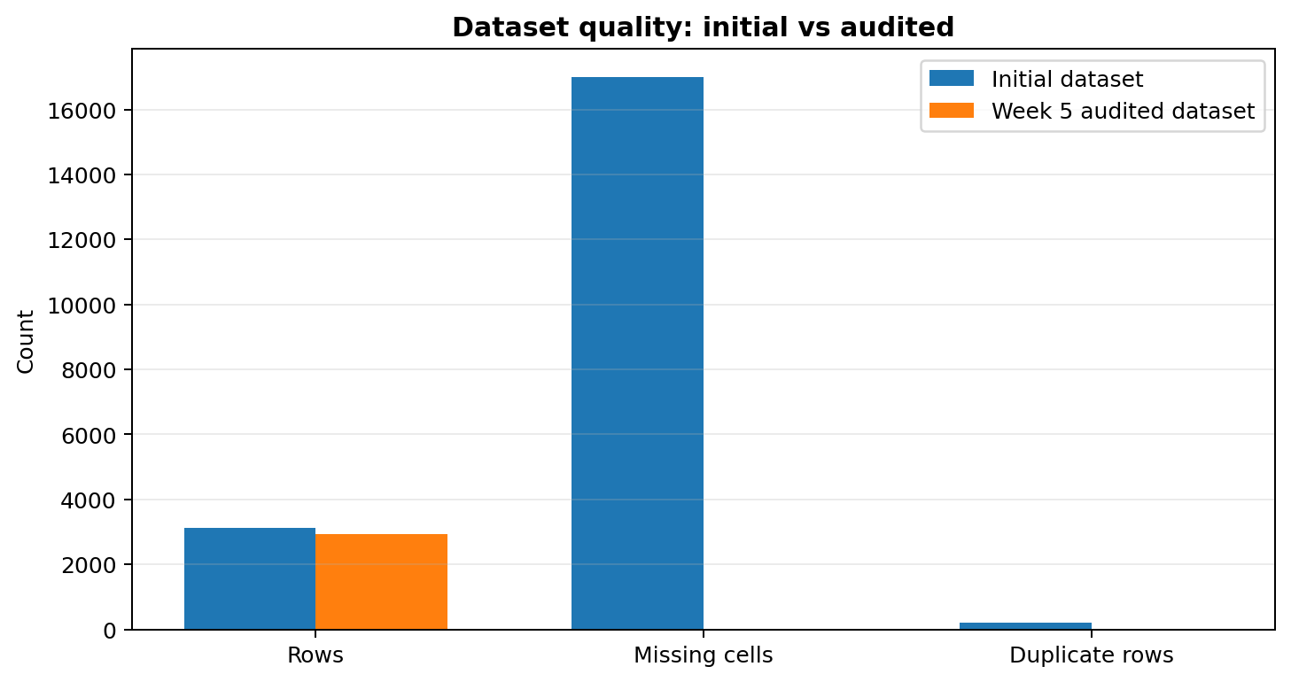
Figure 1. Initial dataset counts compared with the audited state. Counts are shown as reported.
Metric | Before cleaning | Intermediate Week 3 comparison | Week 5 audit
Rows | 3,130 | 2,930 | 2,930
Columns | 82 | 82 | 82
Missing cells | 17,010 | 15,066 | 0 reported
Duplicate rows | 200 | 0 | 0

Cleaning decisions
- Treat missingness according to meaning: a blank garage, pool, alley or basement field may indicate that the feature is absent rather than unknown.
- Use 'None' for categorical fields when the record indicates that an amenity is absent, as described in the weekly report.
- The reports describe median imputation for remaining numerical gaps and mode imputation for remaining categorical gaps; Lot Frontage is specifically reported as median-imputed.
- Screen potential outliers using boxplots and a |Z|>3 rule, but do not automatically delete an extreme observation without evidence that it is invalid.

Outlier screening results
Variable | Potential outliers before | After | Difference
SalePrice | 48 | 45 | 3
Gr Liv Area | 27 | 25 | 2
Total Bsmt SF | 22 | 21 | 1
1st Flr SF | 31 | 29 | 2
Garage Area | 17 | 17 | 0

The cleaning work took place in stages. Week 3 still recorded 15,066 missing cells in its comparison, while the later Week 5 audit reported zero after further imputation. The figures refer to different stages of the process.

5. Exploratory Data Analysis and Visualization
Week 2 and Week 4 use histograms, density curves, boxplots, scatterplots, count plots, grouped comparisons and a Pearson correlation heatmap. Together, these views examine individual distributions and relationships between property characteristics and sale prices.

5.1 Sale price distribution
The sale-price distribution is right-skewed. In simple terms, many homes fall within the lower and middle price ranges, while a smaller number of expensive homes pull the distribution toward higher values. The Week 5 report gives a skewness of +1.74. It also reports an average sale price of $180,796.06 and a median of $160,000, showing that the average is lifted by higher-priced properties.
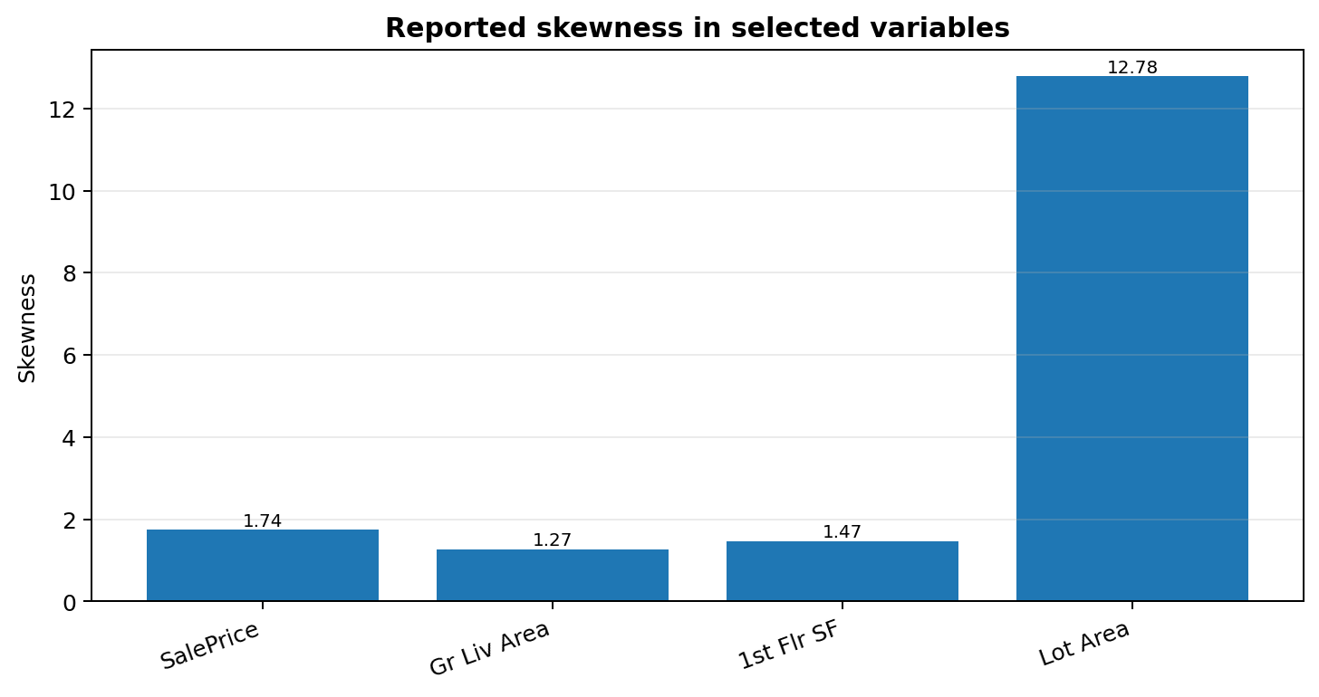
Figure 2. Reported skewness for selected variables. Lot Area has an especially large positive skewness value.

5.2 Relationship with quality and living area
The Week 2 and Week 4 visualizations show two clear patterns: homes with higher Overall Qual ratings tend to sell for more, and homes with larger above-ground living areas (Gr Liv Area) also tend to have higher prices. The relationship is not exact, however. Two homes of similar size can sell for different prices because location, age, garage space, basement features and other characteristics also play a role.

5.3 Correlation analysis
The Week 5 report gives the following Pearson correlations with SalePrice:
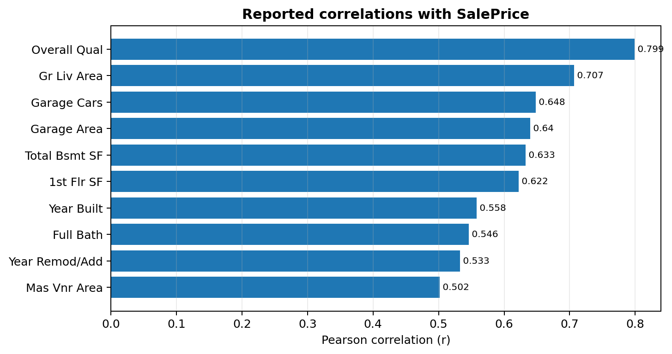
Figure 3. Correlation coefficients reported in Week 5. Values closer to +1 indicate stronger positive linear association.
Overall Qual has the strongest reported correlation (r = +0.799), followed by Gr Liv Area (+0.707), Garage Cars (+0.648), Garage Area (+0.640) and Total Bsmt SF (+0.633). Correlation is useful for screening but does not establish causality and may miss non-linear effects.

6. Descriptive Statistical Findings
Feature | Mean | Median | Std. dev. | Min | Max
SalePrice | $180,796.06 | $160,000 | $79,886.69 | $12,789 | $755,000
Gr Liv Area | 1,499.69 | 1,442 | 505.51 | 334 | 5,642
Overall Qual | 6.09 | 6 | 1.41 | 1 | 10
Year Built | 1971.36 | 1973 | 30.25 | 1872 | 2010
Total Bsmt SF | 1,051.26 | 990 | 440.97 | 0 | 6,110
Garage Cars | 1.77 | 2 | 0.76 | 0 | 5
Garage Area | 472.66 | 480 | 215.19 | 0 | 1,488
1st Flr SF | 1,159.56 | 1,084 | 391.89 | 334 | 5,095

The average sale price is about $20,796 higher than the median, which supports the finding that the price distribution is right-skewed. By comparison, Overall Qual has a mean of 6.09 and a median of 6, so its values are more balanced around the centre.

7. Feature Engineering, Transformation and Scaling
In Week 6, we created five new features by combining existing columns. These features describe the age of a home, how recently it was remodelled, its total bathroom capacity, its outdoor living space and its combined living and basement area. The idea is to give later analysis a more useful summary of related property details.
Engineered feature | Definition in the weekly report | Interpretation
HouseAge | Yr Sold − Year Built | Property age at the time of sale.
RemodAge | Yr Sold − Year Remod/Add | Years since remodeling or addition.
TotalBathrooms | Full Bath + 0.5×Half Bath + Bsmt Full Bath + 0.5×Bsmt Half Bath | Combined bathroom capacity.
TotalPorchArea | Open Porch SF + Enclosed Porch + 3Ssn Porch + Screen Porch + Wood Deck SF | Combined outdoor living area.
TotalHouseArea | Gr Liv Area + Total Bsmt SF | Combined above-ground living and basement area.

7.1 Target transformation
Week 6 applied the log1p transformation, calculated as log(1 + SalePrice), to reduce the strong skew in sale prices. According to the report, skewness dropped from +1.74 to +0.12 after the transformation. This makes the distribution much more balanced and may be useful for some modelling methods. Its benefit should still be checked when the prediction model is tested.
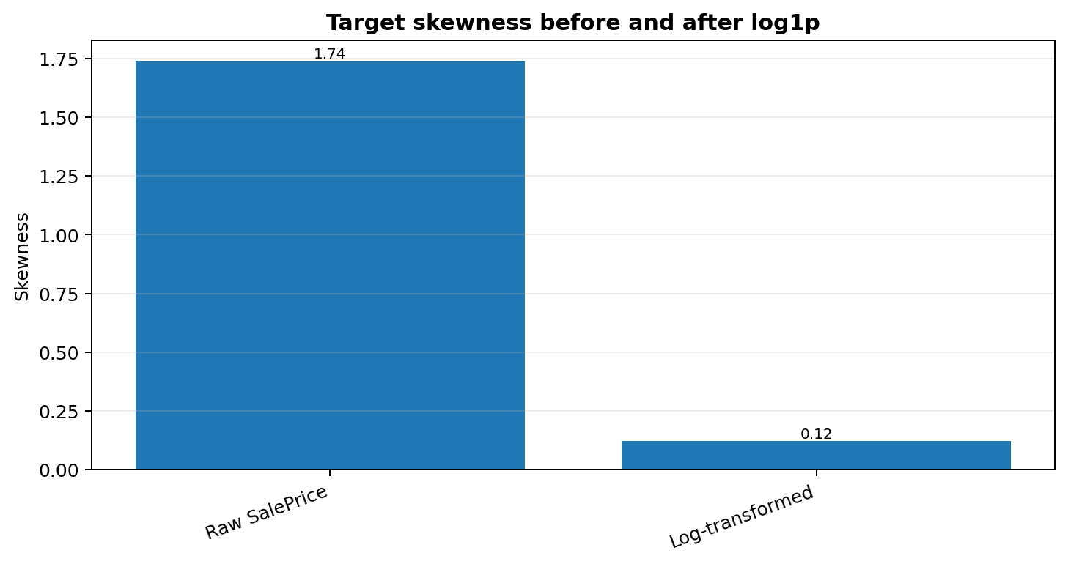
Figure 4. SalePrice skewness before and after the reported log1p transformation.

7.2 Scaling methods
Method | Formula / behaviour | Reported use case
Min-Max normalization | (X − Xmin) / (Xmax − Xmin); maps values to [0, 1]. | Useful when bounded input ranges are desired.
StandardScaler | (X − mean) / standard deviation; mean 0 and standard deviation 1. | Useful for many linear and distance-based methods.
RobustScaler | (X − median) / IQR; uses median and interquartile range. | Less sensitive to extreme values.

Week 6 reports that StandardScaler outputs have mean 0 and standard deviation 1 for the example features. Robust scaling is presented as an option for outlier-prone features. Scaling should be fitted on training data only when a predictive model is developed, to avoid information leakage.

7.3 Categorical encoding
- Ordinal encoding maps ordered quality categories to ranked numeric values (the report gives None: 0, Po: 1, Fa: 2, TA: 3, Gd: 4, Ex: 5).
- One-hot encoding represents nominal categories as separate binary columns without imposing a false numeric order.
- The reported matrix expands from 82 original columns to 293 encoded/engineered columns (2,930 rows).

8. Feature Selection and PCA
By Week 7, preprocessing had produced 279 numerical feature columns for analysis, after identifiers and target columns were separated and redundant text columns were removed. We then explored feature selection and PCA to reduce unnecessary information, limit redundancy and make the data easier to work with.

8.1 Feature selection methods

Method | Purpose | Reported result
Low-variance threshold | Remove sparse dummy columns with little variation. | 88 columns dropped; 191 active features retained at this stage.
Correlation and multicollinearity review | Find useful target associations and reduce redundant pairs. | Overall Qual and TotalHouseArea are among the strongest associations with SalePrice_Log.
ANOVA F-regression (SelectKBest) | Score individual features for linear association with the log target. | Some continuous dimensions and quality features have F-scores above 5,000.
Random Forest importance | Capture non-linear relationships and interactions. | Overall Qual 49.73%; TotalHouseArea 28.05% of reported importance.

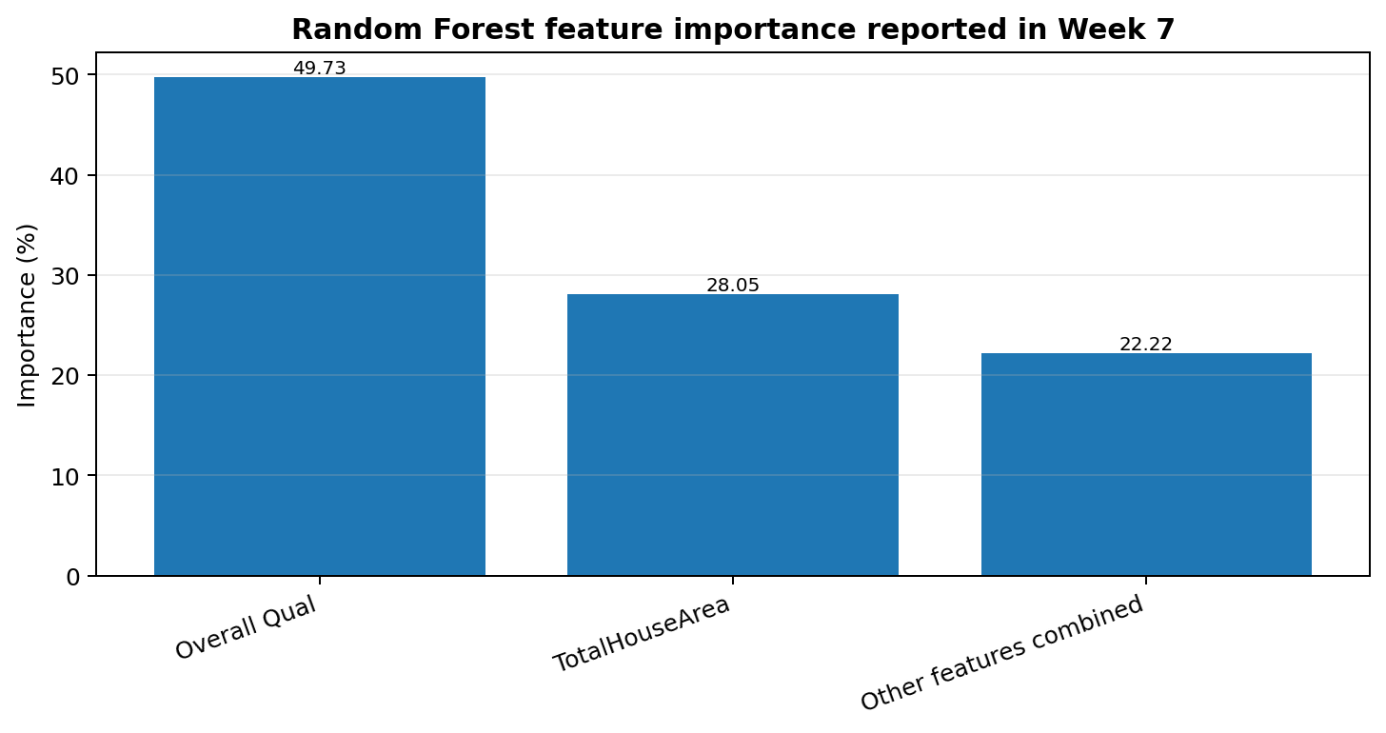
Figure 5. Random Forest importance reported in Week 7.
The report states that the top 40 non-collinear features were curated using Random Forest importance and F-regression. The resulting Selected_Features_AmesHousing.csv contains 2,930 rows and 44 columns, including identifiers and target values.

8.2 PCA and explained variance
PCA, or Principal Component Analysis, combines information from the standardized input features into new variables called principal components. These components are uncorrelated with one another and are ordered by how much variation in the data they explain. The Week 7 report standardized all 279 features first so that measurements with larger numerical ranges would not dominate the analysis simply because of their scale.
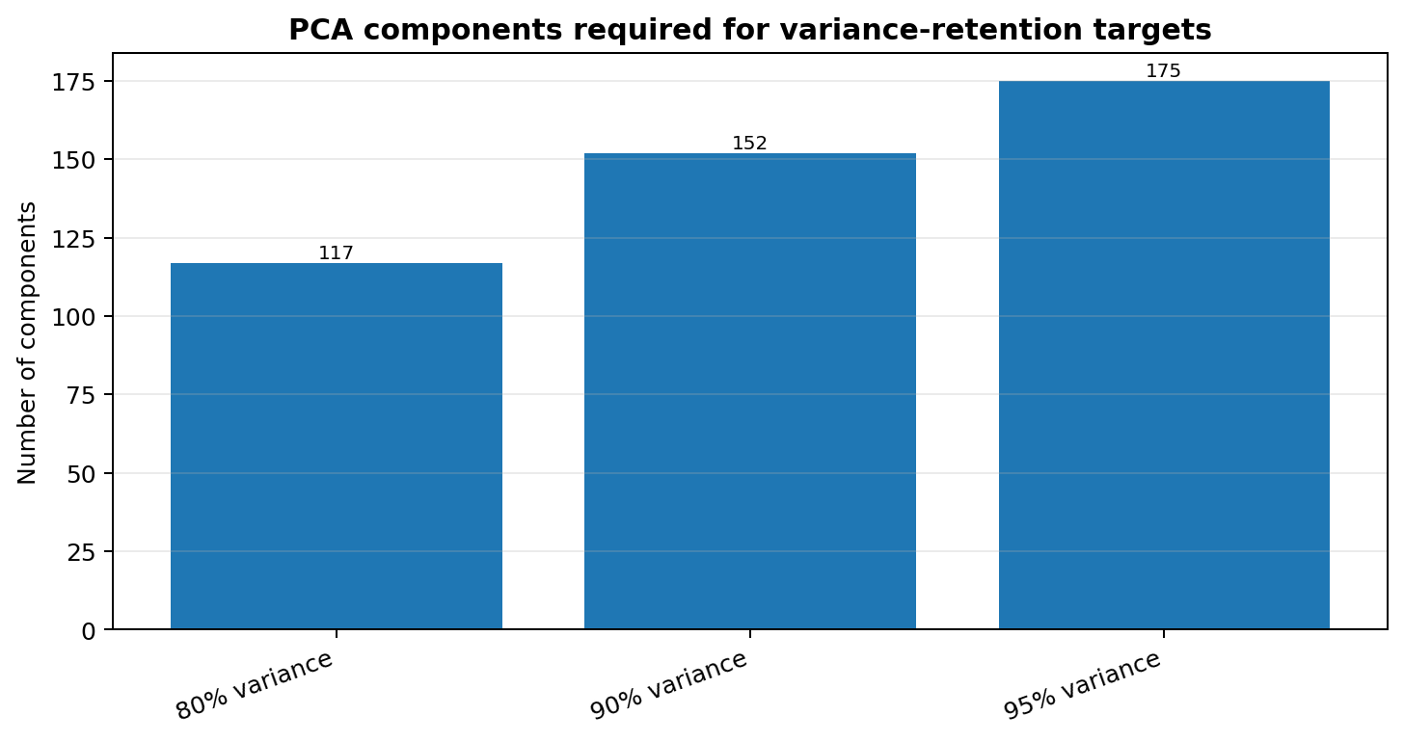
Figure 6. Number of principal components reported as necessary to reach each cumulative variance threshold.

Variance retained | Components required | Dimensionality reduction
80% | 117 | 58.1%
90% | 152 | 45.5%
95% | 175 | 37.3%

PC1 explains 6.90% of variance, PC2 explains 2.89%, and PC3 explains 2.37%; PC1 and PC2 together explain 9.79%. The report interprets PC1 mainly as a size, modernity and construction-quality dimension, while PC2 reflects architectural structure and property type.

8.3 Feature selection compared with PCA
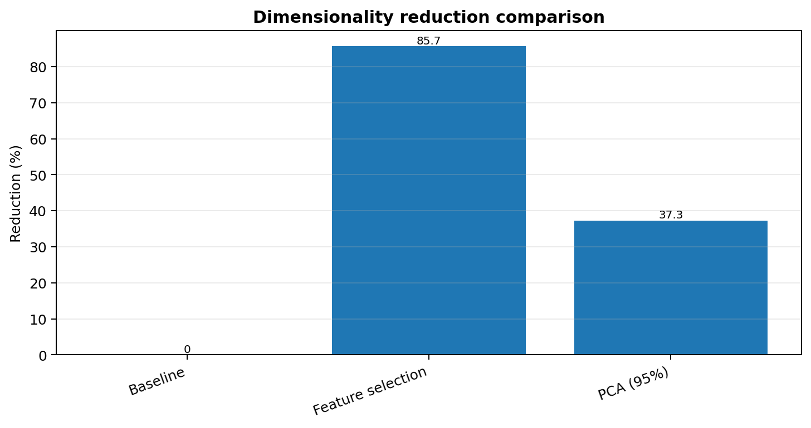
Figure 7. Reported dimensionality reduction for curated feature selection and PCA retaining 95% variance.

Criterion | Curated feature selection | PCA at 95% variance
Predictor representation | 40 original, named features | 175 principal components
Reduction from 279 input features | 85.7% | 37.3%
Interpretability | High; features retain domain names | Lower; components combine many features
Correlation structure | Reduced by pruning redundant features | Principal components are orthogonal
Best fit described in report | Interpretable regression and linear models | Regularized regression, SVD and clustering

The Week 7 PCA output is reported as 2,930 × 179, representing 175 principal components plus identifiers and targets. The curated feature-selection output is reported as 2,930 × 44.

9. Integrated Interpretation
Looking back across the seven weeks, the project has moved from checking the quality of the raw data to preparing a more compact dataset for future prediction. A few important lessons emerged from this process:
- Property quality is a leading price signal: Overall Qual has the strongest reported correlation with raw SalePrice and dominates the reported Random Forest importance ranking.
- Size matters, but does not explain everything: Gr Liv Area and TotalHouseArea are strong signals, while scatterplots show that prices vary at similar sizes.
- Data preparation affects reliability: duplicate removal, explicit treatment of amenity absence, imputation and outlier review provide a cleaner base for analysis.
- Transformations can improve modelling suitability: the reported log transformation substantially reduces target skewness.
- Dimensionality reduction has a trade-off: feature selection preserves interpretability, whereas PCA retains a chosen amount of variance in fewer orthogonal dimensions but reduces direct feature-level explanation.

10. Limitations and Reporting Notes
- The weekly reports describe exploratory analysis and preprocessing; no final model accuracy, train/test evaluation or deployment result is included in the supplied material.
- The Week 3 report gives an intermediate missing-cell count of 15,066, while Week 5 reports zero after the later audit. This consolidated report preserves the staged interpretation.
- Week 4 states that some observations should be finalized after running the notebook; this report therefore uses quantified results only where later weekly reports provide them.
- Feature importance and correlation are not causal explanations. Results can also depend on preprocessing choices and the data split used during eventual model training.
- PCA variance retained is not the same as prediction accuracy retained. A downstream model must be validated before selecting a final representation.

11. Conclusion and Next Steps
Overall, the seven weeks have built a step-by-step workflow for working with the Ames Housing dataset. We started by understanding the data, then cleaned and audited it, explored important patterns, created new features, scaled and encoded the variables, and finally tested feature selection and PCA. The Week 5 audit reports 2,930 records, 82 original columns, no missing values and no duplicate rows. Week 6 expanded the dataset to 293 columns, while Week 7 produced a selected set of 40 features and a PCA version using 175 components to retain 95% of the reported variance.
To continue the project, the next useful steps are:
- Train baseline regression models (for example, linear regression and a tree-based regressor) using a train/validation/test split.
- Fit imputation, scaling and encoding steps on training data only, then apply the same fitted transformations to validation and test data.
- Compare raw SalePrice versus SalePrice_Log modelling and report MAE, RMSE and R² on held-out data.
- Compare model performance and runtime using the curated feature set versus PCA components.
- Document the exact data version, preprocessing configuration, random seed and model settings to make results reproducible.

Appendix: Reported output artifacts
Artifact | Reported role
Cleaned_AmesHousing_Week5.csv | Audited cleaned dataset used by Week 6.
Feature_Engineered_AmesHousing.csv | Week 6 scaled and encoded matrix; 2,930 × 293.
Selected_Features_AmesHousing.csv | Week 7 curated feature set; 2,930 × 44.
PCA_Transformed_AmesHousing.csv | Week 7 PCA matrix; 2,930 × 179 including IDs and targets.
EDA Deep Dive.ipynb / correlation_matrix.csv | Week 4 notebook and reported correlation output.

